Toft’s VE Day 80th Anniversary Celebration

Toft celebrated the 80th Anniversary of VE day with it’s usual panache.
The day started with a proclamation and Flag raising on the Green.

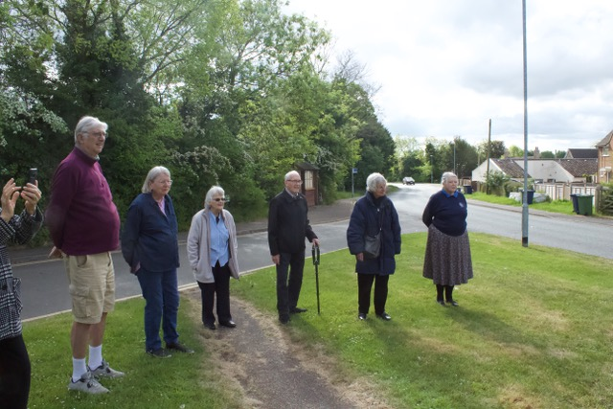
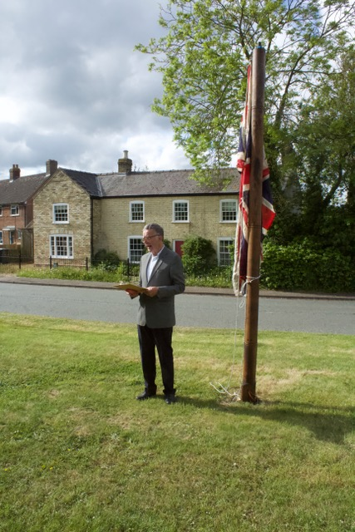

At 6-30pm there was a full house of bell ringers ringing the bells at the Church.

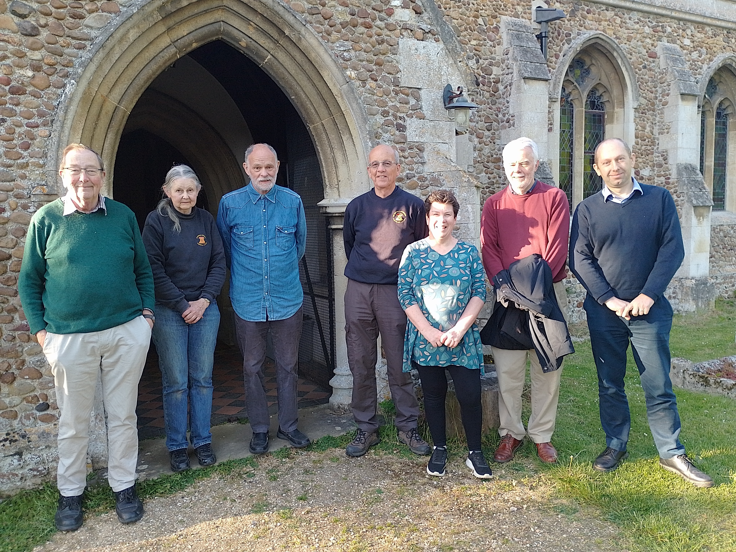

At around 9-30pm on Lot Meadow the Choir sang “I vow to thee My Country”, refreshments were enjoyed and the Beacon was lit.
